**Shipping Data- Power BI Dashboard Report**

This provides a comprehensive analysis of Shipment Operations, Vessel performance, and Cargo Type movement patterns. It integrates multiple KPIs and visualizations to help team and stakeholders in evaluating efficiency, volume, and delivery performance across countries, vessels, and estimated time frame.

**Bookmark Name: ‘All Data’**

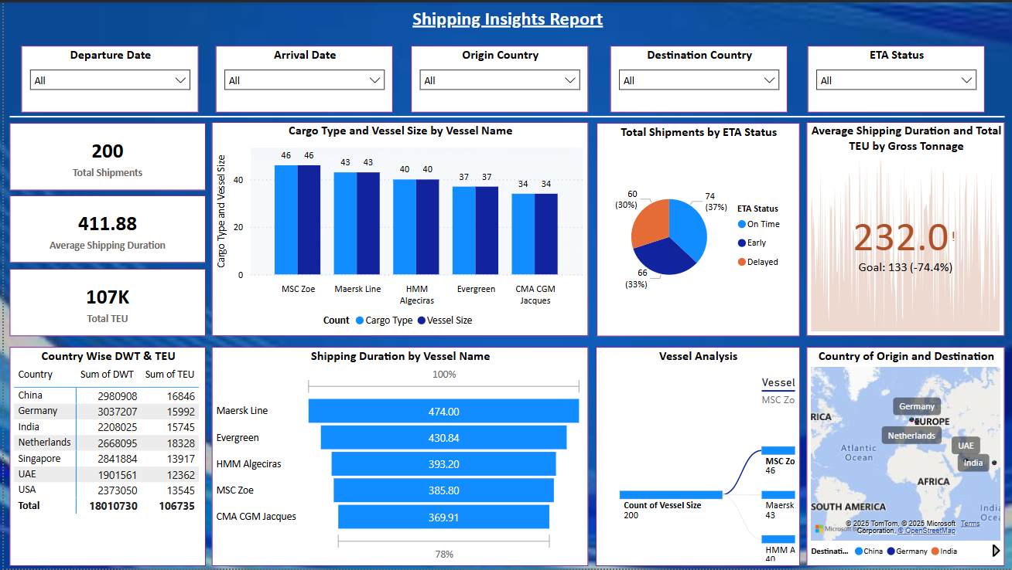

**Bookmark Named: ‘Year 2023 Departure’, ‘Year 2024 Departure’ and ‘Year 2025 Departure’**

Provides insights based on that particular year. Below are screenshots for same respectively.

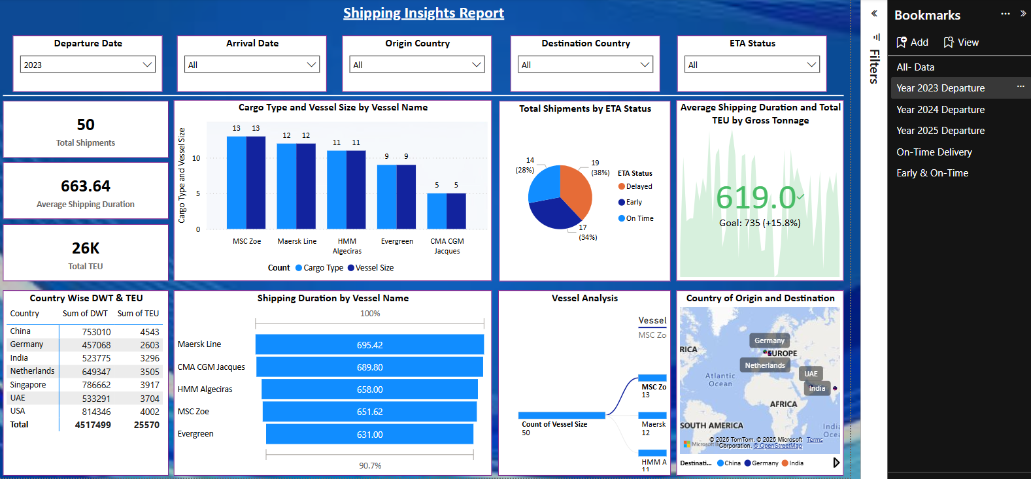

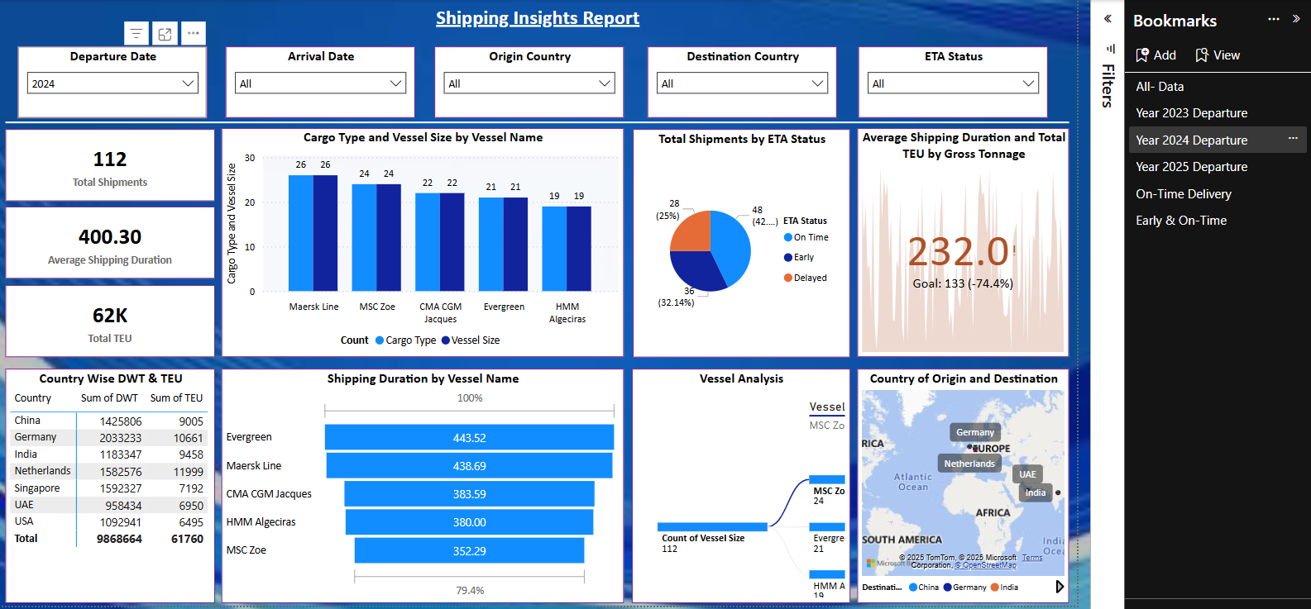

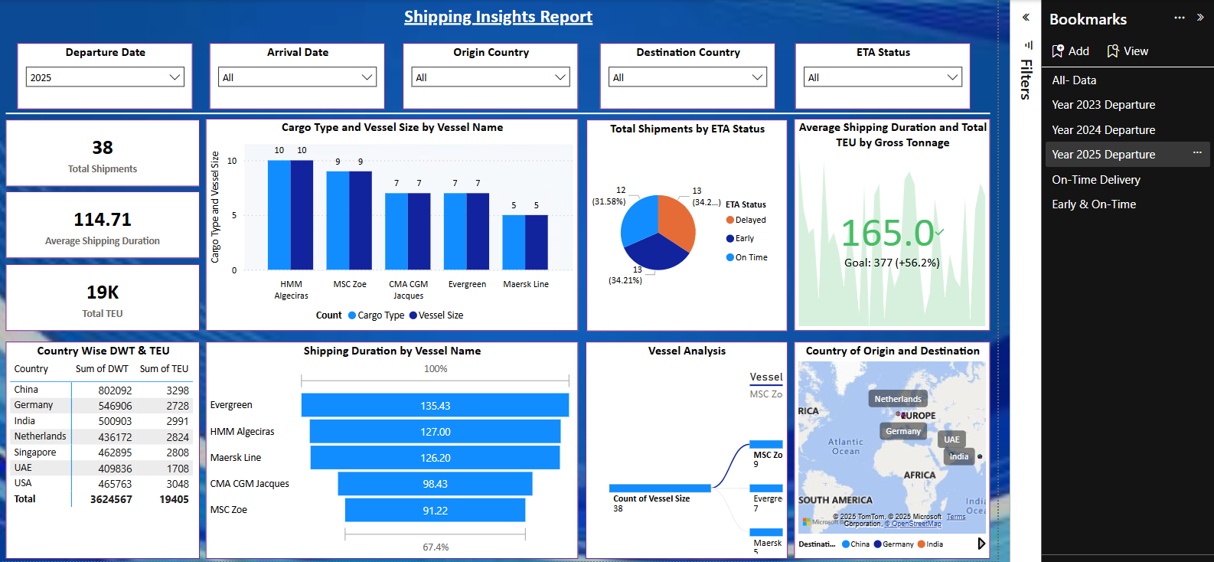

**Bookmark Named: ‘On-Time Delivery’ and ‘Early & On-Time’**  
Provides insights based on ETA Status. Below are screenshots for same respectively.